**School of Computer Applications**

**Union Christian College, Aluva**



**Software Design Specification**

**On**

**REAL-TIME YOGA POSTURE PREDICTION**

**AND CORRECTION**

ANUGRAH N P

4 C - 11

Submitted by:

Internal Guide:

Ms. AMRUTHA KARTHIKEYAN

Assistant Professor

MCA Department

UC College, Aluva

Submitted on : 20/09/2022

Table of Contents

Contents

1 Introduction 3

1.1 Purpose 4

1.2 Scope 4

1.3 Definitions & Acronyms 4

2 Decomposition Description 5

2.1 Logging in and selecting pose to train 5

2.2 Pose estimation 5

2.3 Pose Comparison 6

2.4 Pose Classification 8

2.5 Feedback to the Users 11

3 Domain Model 12

4 Use Case Model 13

5 Design Model 14

5.1 Activity diagram 14

5.2 Sequence Diagrams 15

5.3 UI design 16

5.4 Theoretical Background 17

6 References: 18

# Introduction

Nowadays, yoga has become a part of life for many people. Exercises and sports technological assistance is implemented in yoga pose identification .Self-learning is an integral part in Yoga, but incorrect posture while performing yoga can lead to serious harm to muscles and ligaments of the body. Thus to prevent this I present an intuitive approach based on machine learning techniques to correct the practitioner’s pose while performing various yoga asanas. The proposed system is aimed at providing concise feedback to the practitioner so they are able perform yoga poses correctly and assist them in identifying the incorrect poses and suggest a proper feedback for improvement in order to prevent injuries as well as increase their knowledge of a particular yoga pose. By using such a system, a whole yoga class atmosphere can be created at the user’s home where the yoga pose is detected and corrected by the system automatically using mediapipe algorithm. It extracts body landmarks of each of the keypoints to enable angle calculation of each body joint and provide necessary instructions to user to correct the yoga pose.So that proper instructions can be delivered to help them in very convenient manner so that they can adjust their poses and learning about their incorrectness in real time. There is also an increasing demand for the development of computer-assisted training systems from the practitioner side to help them to improve their knowledge and understanding about different types of yoga poses and also protect them from injury that might occur during learning phases.

## Purpose

The project’s major purpose is to:

• Different yoga postures were collected from camera, and learners were required to perform each yoga posture.

• It can evaluate pose quality; Which can distinguish different movements by analyzing pose characteristics.

• Therefore, automatically evaluating yoga poses and providing suggestions to alert learners using mediapipe algorithm.

## Scope

Self-learning is an integral part in Yoga .The practitioner have to follow certain steps and guidelines for taking maximum benefit from a particular pose and in lot of cases failing to do so may lead to serious harm due to incorrect postures. If these incorrect practices are continued for a prolonged period it may lead to long-term pain in the joint. This became the prime motivation for developing a yoga self-training systems for practitioner to exercise on their own with the help of a web based application, so that proper instructions can be delivered to help them in very convenient manner so that they can adjust their poses and learning about their incorrectness in real time and there is also an increasing demand for the development of computer-assisted training systems from the practitioner side to help them to improve their knowledge and understanding about different types of yoga poses and also protect them from injury that might occur during learning phases

## Definitions & Acronyms

SDS :System Design Specifications

UML :Unified Modelling Language

# Decomposition Description

## Logging in and selecting pose to train

Here our Yoga Webpage will be displayed and user needs to login if they have an account or create account if don’t, and login to the web page where there will be different yoga poses mentioned. User can select the pose they want to perform and by selecting, real time camera will be opened at that time. Now User can perform the yoga pose.

## Pose estimation

Media Pipe is a framework for high-fidelity body pose tracking, which takes input from RGB video frames and infers 33 3D landmarks on the whole human. For instructional feedback , the keypoint of the human body was estimated using mediapipe algorithm. It extracts body landmarks of each of the keypoints to enable angle calculation of each body joint. Eg, left/right shoulder, left/right elbow ,left/right wrist , left/right hip , left/right knee and left/right ankle. We can use Openpose instead of mediapipe. OpenPose is an open-source real-time multiple- person detection system, to jointly detect human body, palm, facial, and foot key points .But it detects 15, 18, 27 body/foot landmarks. But mediapipe detects 33 keypoints. Working with OpenPose was very slow relative to MediaPipe. It takes a relatively long time to process videos and takes a lot of computing power even on decent machines. So here each yoga pose can be detected and corrected using mediapipe.

## Pose Comparison

The output from the MediaPipe library only contains the coordinates of the user’s major key-points in the image. A function is written in the program to get these coordinates data and then calculate the angles at each joints for eg. at elbows, shoulders, hips etc. Given three key-points we can easily calculate the angle made between the two lines using analytic geometry. Let A(x1, y1), B(x2, y2) and C(x3, y3)be the three points. Let the lines AB and BC intersect at B, then the angle between AB and BC can be calculated as: Slope of the line AB is given as,

1) m1=(y2-y1)/(x2-x1)

m1 is the slope between the line joining the point A and B. y1 and x1 are the coordinates of point A and x2 and y2 are the coordinates of point B. This same principle is then again applied on the line BC to get the slope of line BC. Slope of the line BC is given as,

2) m2= (y3-y2)/(x3-x2)

m2 is the slope between the line joining the point B and C. y2 and x2 are the coordinates of the point B and x3 and y3 are the coordinates of point C.The point B is the common point between the three points A, B and C and so the angle is formed at the joint B. This is the angle between AB and BC. Now, the angle between AB and BC can be calculated as,

3)tan θ = m1−m2/1+m1.m2

In Eqn. 3, the tan is calculated which can be either positive or negative based on the angle given. By taking the inverse of the tan we get the angle made at B between AB and BC. AB and BC can be considered as two bones or skeletal structures of the human body. Assuming the line AB as the elbow and line BC as the hand, the angle made between the elbow and hand can be calculated in this manner. On further applying this analysis to all the other joints we can calculate the angles made at each joint. These angles are calculated for all the 6 yoga poses.during a yoga routine the user may not always be in the center of the frame. So the measurements will keep on changing. But if the user is assumed as the center then the angles can be measured by keeping the user as the center. Therefore even if the user is not at the center of the frame we can calculate the angles because the angle calculation is done by keeping the user as the center point.

## Pose Classification

Create a function that will be capable of classifying different yoga poses using the calculated angles of various joints. The function will be capable of identifying the following yoga poses:

**Tree pose**

Tree Pose (also known as Vrikshasana) is another yoga pose for which the person has to keep one leg straight and bend the other leg at a required angle. The pose can be classified easily using the following combination of body part angles:

• Around 180° angle at one knee.

• Around 35° (if right knee) or 335° (if left knee) angle at the other knee.

**T pose**

T Pose (also known as a bind pose or reference pose), To make this pose, one has to stand up like a tree with both hands wide open as branches. The following body part angles are required to make this one:

• Around 180° at both elbows

• Around 90° angle at both shoulders

• Around 180° angle at both knees

**Mountain pose**

Though Tadasana (Mountain Pose) might seem simple, it is actually a deeply vital foundational pose for your yoga practice. It is a basic yoga pose where the yogi plants their feet on the ground as their body stands firm and straight.

• Around 180°angle at both knees

• Around 20° angle at both shoulders

**Goddess pose**

Goddess Pose or Utkata Konasana, is a powerful pose that strengthens the feminine power and helps you connect to the space just beneath and behind your navel that is described as your energetic center. Goddess pose is a squat. Your thighs and entire lower body will turn on and tone. Because the feet are turned out and you sit down, not back, your inner thighs will get a nice stretch and tone. In addition, goddess pose works the core muscles, chest, and back as you hold the posture.

• Around 90°angle at both Shoulder

• Around 90°angle at both Elbow

• Around 100°angle at both Knees

**Warrior-I pose**

Warrior I stretches your chest, lungs, shoulders, neck, belly and groin. It also strengthens your shoulders, arms, and back muscles, as well as your calves, ankles, and thighs.Keep your upper body facing the front edge of the mat and your shoulders level. Bend your right knee, the right thigh towards parallel to the floor. Keep the weight in the front heel and big toe. Press the back foot down and lift from the inner arch. Check if one leg is straight

• Knee around 170°

Check if the other leg is bended at the required angle

• Knee around 100°

• Shoulder around 220°

• Elbow around 180°

**Warrior-II pose**

Warrior II pose, or Virabhadrasana II in Sanskrit, is a standing yoga posture that stretches the shoulder, chest, and groin, and builds strength in the legs, torso, and spine. Warrior II is one of five other warrior poses in a modern yoga practice. It can be classified using the following combination of body part angles:

• Around 180° at both elbows

• Around 90° angle at both shoulders

• Around 180° angle at one knee

## Feedback to the Users

Giving feedback to the user is of utmost importance so that the user knows what he/she is doing wrong. This helps in guiding the user to correct posture and thus learning to practice the yoga pose correctly. The feedback regarding the performance of the user is provided in real-time via the display messages. When the user deviates beyond the threshold value the user is notified. Users can observe the correction and make necessary adjustments to his/her pose to accurately practice the yoga routine. The feedback can be in the form of a visual alert on the screen. Each user has varying levels of flexibility that is, one user may not be able to bend or flex his/her body as much as the other user. So in order to tackle that issue, a user-changeable threshold parameter is included. Each user can set the threshold as per his/her requirements. A new user can set the threshold, to say 20 degrees so that he/she can have a deviation of about 20 degrees in either direction. An experienced user can set it to less than 10 degrees so that he/she can practice the pose accurately. This feature allows even beginner users to slowly and steadily improve his/her body flexibility to do yoga.

# Domain Model

Domain model is a system of abstraction that describes selected aspects of a sphere of knowledge or a domain. This model is used to generate solutions to the problem statement.

# Use Case Model

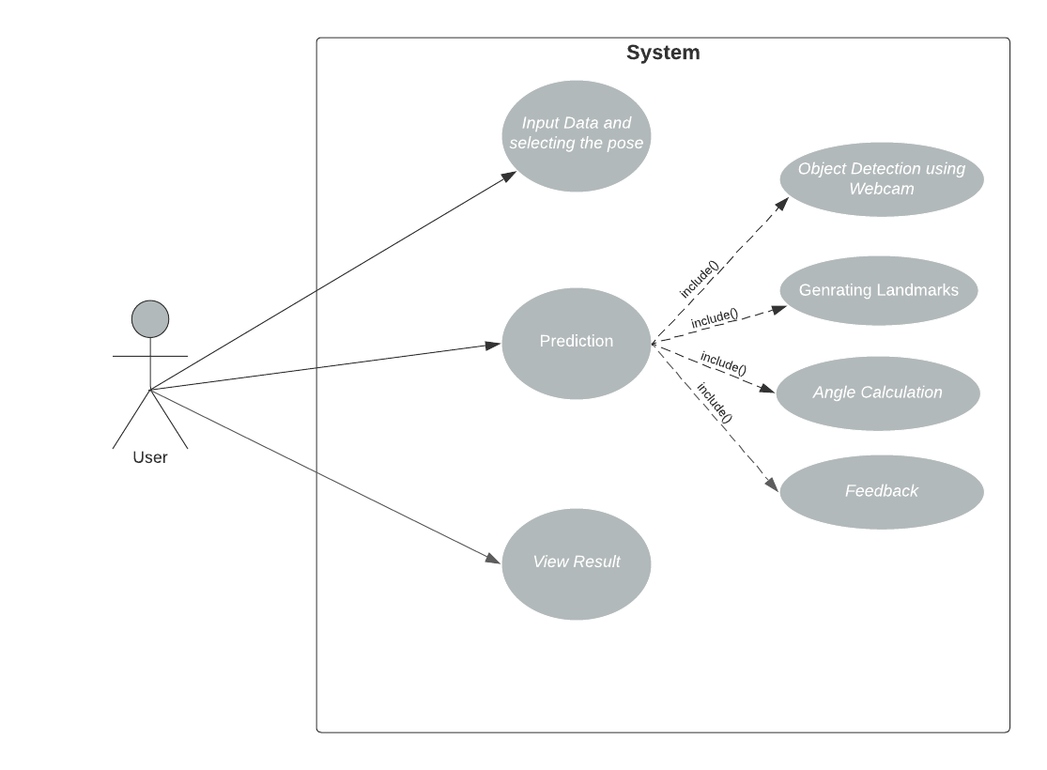

# Design Model

## Activity diagram

Activity diagram is describing the dynamic aspects of the system. Activity diagram is basically a flowchart to represent the flow from one activity to another activity. The activity can be described as an operation of the system. The control flow is drawn from one operation to another.

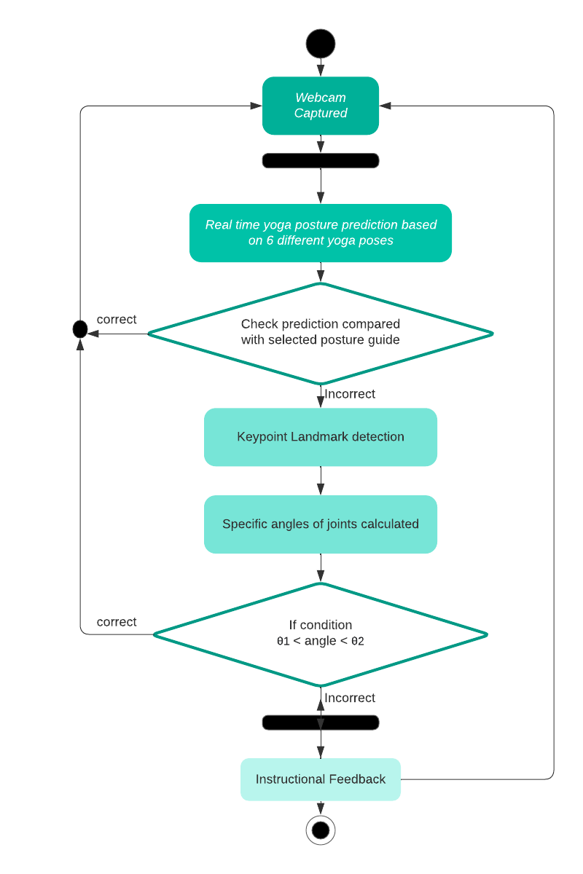

## Sequence Diagrams

In this project sequence diagram shows object interaction arranged in time sequence it is typically associated with use case realizations in the logical view of the system under devolvement.

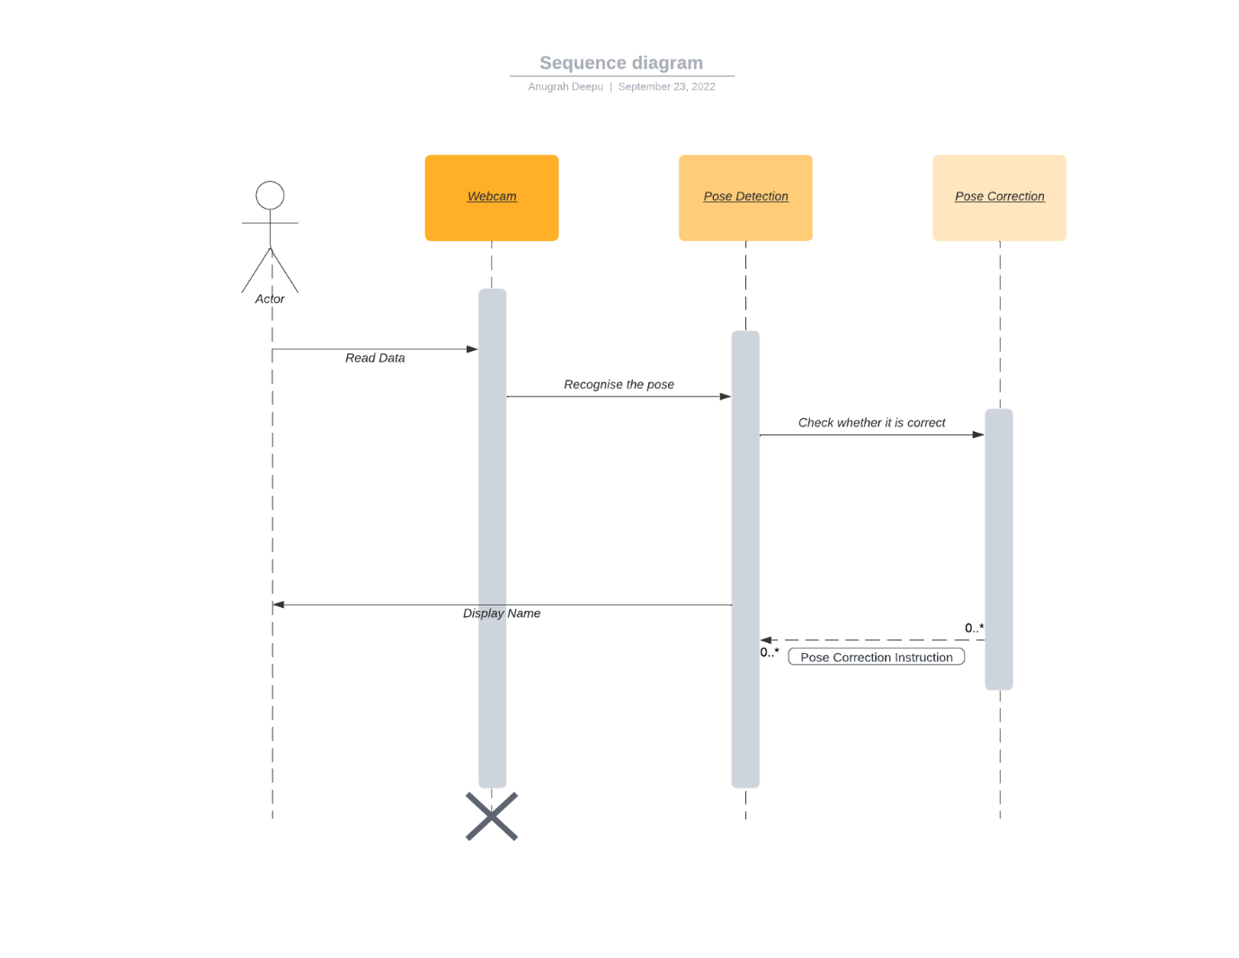

## UI design

User interface design usually the primary interface for human machine interaction. In this project use library that follows material design constraints.

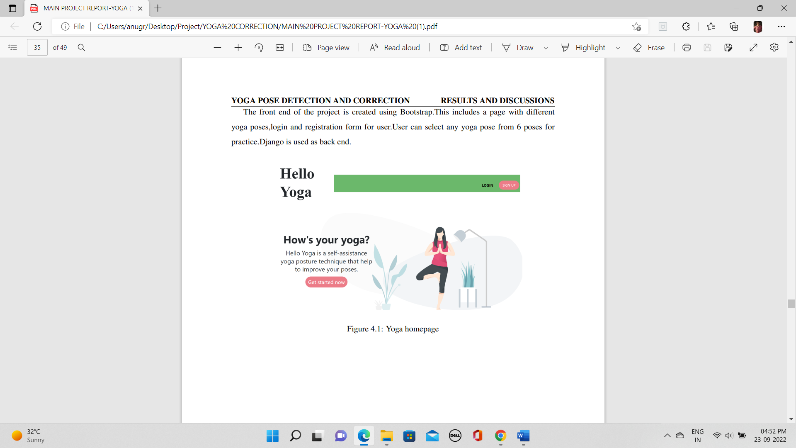

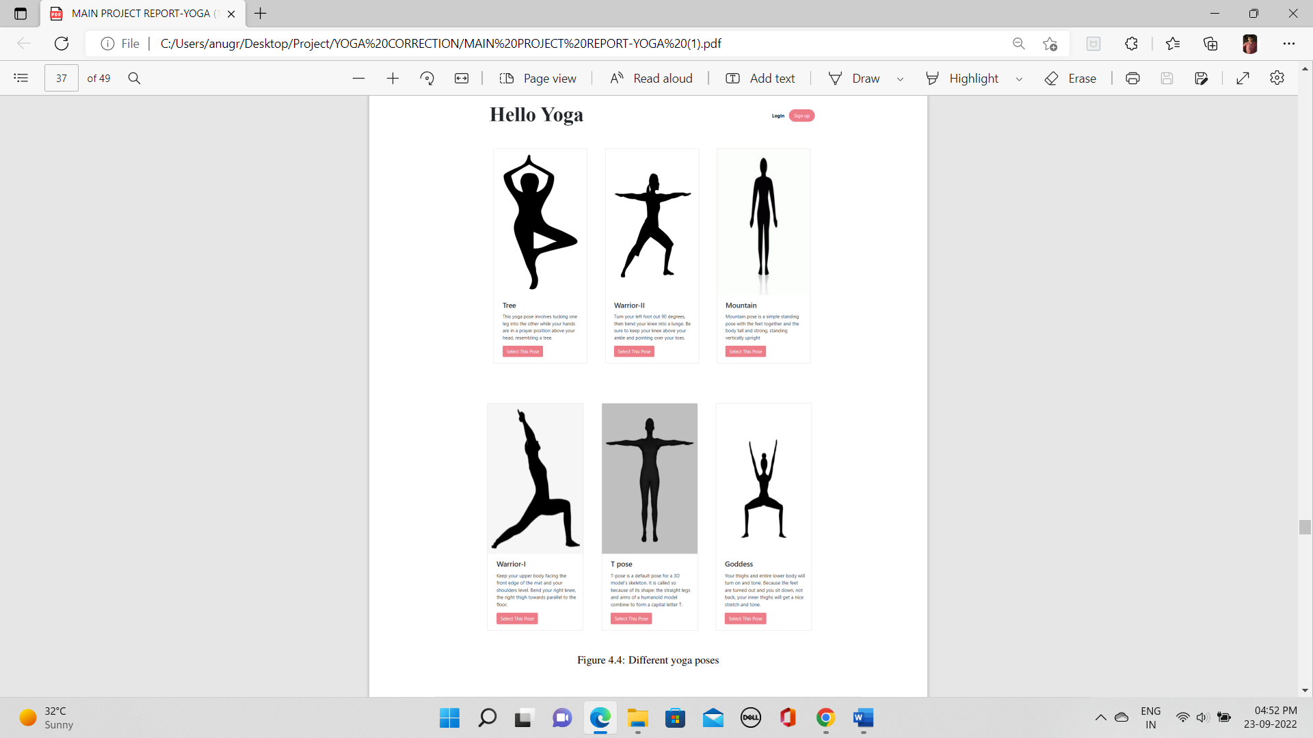

## Theoretical Background

**HARDWARE SPECIFICATION:**

CPU - intel i3 Processor or Above

Hard Disk - 40 GB

Display - 15”Color Monitor

Main Memory - 4GB

Keyboard - 104 Keys

Clock-Speed - 2.6 GHZ

Monitor - 15”CRT Monitor

**SOFTWARE SPECIFICATIONS**

The tools used for the project are :

• Python

• Jupiter Notebook

• Django

• HTML

• CSS

• Bootstrap

# References:

[1] F. Rishan, B. De Silva, S. Alawathugoda, S. Nijabdeen, L. Rupasinghe and C. Liyanapathirana, ”Infinity Yoga Tutor: Yoga Posture Detection and Correction System,” 2020 5th International Conference on Information Technology Research (ICITR), 2020, pp. 1-6, doi10.1109/ICITR51448.2020.9310832.

[2] Agrawal, Y., Shah, Y., Sharma, A. ”Implementation of machine learning technique for identification of yoga poses”. In 2020 IEEE 9th International Conference on Communication Systems and Network Technologies (CSNT),2020, 40–43.doi:10.1109/CSNT48778.2020.9115758

[3] Anilkumar, A., K.t., A., Sajan, S., K.a., S, ”Pose Estimated Yoga Monitoring System”, SSRN Electronic Journal. doi:10.2139/ssrn.3882498 Zhang Z (2012) Microsoft kinect sensor and its effect, IEEE Multi 19:4–10. https://doi.org/10.1109/ MMUL.2012.24

[4] Chun J, Park S, Ji M ,” 3D human pose estimation from RGB-D images using deep learning method”. In: Proceedings of the 2018 International Conference on Sensor, Signal and Image Processing, 2018,pp 51–55, https://doi.org/10.1145/3290589.3290591

[5] Kadbhane,S., Datir,K., Jagdale,T., Dhongade,S., Jagtap,G.”Yoga Posture Recognition”, International Journal of Advanced Research in Computer and Communication Engineering, 2021,143–147. doi:10.17148/IJARCCE.2021.10128

[6] Girija Gireesh Chiddarwar, Abhishek Ranjane, Mugdha Chindhe ,” AI-Based Yoga Pose Estimation for Android Application”, International Journal of Innovative Science and Research Technology,2020.